

A

**PROJECT REPORT**

ON

**VISUAL IMPARITY READING ASSISTANT**

**For the award of**

**ONTARIO GRADUATE CERTIFICATE**

Submitted By

**Qutubuddin Bokahri Syed Mohammed C0686424**

**Karteek Kadari C0688776**

Under the Esteemed Guidance of

**Prof. Mike Aleshams PhD**

**DEPARTMENT OF EMBEDDED SYSTEMS ENGINEERING DESIGN**

**LAMBTON COLLEGE IN TORONTO**

**(2016-2018)**

**ABSTRACT**

Raspberry Pi is a single board system with a fast processor which has its wifi,and Bluetooth modems followed by an HDMI, Ethernet, USB ports and an audio jack. Due to its versatility,it has many applications from beginners learning to expert designing of home automation. The raspberry pi runs on Linux based operating system NOOBS. With the help of raspberry pi, a visually impaired reading assistor has been designed which assists an individual with visual imparity by reading the documents

This project report provides an overview of how a single board system interfaced with the external hardware with the help of python-tesseract OCR and Pyttsx libraries. It also provides the advantages of this system over the existing technologies by its simple design and implementation.

**Acknowledgments**

It is a great pleasure to work for under the valuable guidance of Mr.Mike Aleshams. We are thankful for his support, and encouragement throughout the work. His planning and strict adherence to academic schedule helped us to complete the task. We arealways grateful to him.

We would like to acknowledge the management of Lambton College,Toronto for providing necessary infrastructure and LAB facility for executing this work.

We thank all our well-wishers for rendering necessary support during the execution of this work. We appreciate all our family members and friends for their encouragement during the implementation of this work.

BY

Qutubuddin Bokhari Syed Mohammed

(C06868424)

KarteekKadari

(C0688776)

**Table of Contents**

Chapter 1: Introduction 5

Chapter 2: Literature Review 7

Chapter 3: Requirements / Analysis 11

Chapter 4: Design 16

Chapter 5:Implementation And Test 20

Chapter 6:Evaluation 21

Chapter 7:Conclusion 25

Chapter 8: User Manual 26

References 27

List of figures

Fig 2.1 Braille Alphabet 7

Fig 2.2 Finger Mounted Reading Device 8

Fig 2.3 Reader Pen 9

Fig 2.4 SARA Reading Machine 10

Fig 3.1 Block Diagram of the VIRA 12

Fig 3.2 Block Diagram of The Hardware 13

Fig 3.3 Block Diagram of The Software 14

Fig 4.1 Python Code for Start-Event Process 16

Fig 4.2 Python Code for Play-Event Process 17

Fig 4.3 Python Code for Push Button Process 18

Fig 4.4 Hardware Schematic Diagram 19

Fig 6.1 Increasing ARM Frequency and Overclocking CPU 22

Fig 6.2 Disabling GUI for Text Console 22

Fig 6.3 Image Captured by The Camera 23

Fig 6.4 Text Generated After Conversion 24

Fig 8.1 Switches with Various Functions 26

# **Chapter 1: Introduction**

In the daily life of a visually impaired individual, it is tough for an individual to read the documents, books, and articles. This project can overcome these problems. Raspberry Pi used along with the camera, speaker and push buttons which act as an interface between the user and the system.

The Raspberry Pi is a card sized single-board computer with an open-source platform.It can be usedfor various types of projects from beginners learning to expert designing of home automation systems the older models of raspberry pi are pi zero, pi 1 and pi 2.(Jameco, n.d.)

The GPIO header pins used for connecting the tact switches, HDMI port for accessing the GUI, audio and USB ports for interfacing the camera and speaker. The system works by responding to the user’s input it takes the snapshot of the document and converts the text to audio and plays to the user.

For the conversion of the image to text Python Tesseract which is optical character recognization (OCR) tool for python used. Moreover, for text to speech Pyttsx library for Python3 is used.Apart from that google drive, API’s are used to save the audio files of the user on the cloud storage which the can be retrieved by the user any time.

# **Chapter 2: Literature Review**

**Existing System:**

**Braille System:**

Braille is an arrangement of touch reading and writing for visually impaired people in which raised spots to speak to theletter of the alphabet. Braille read by moving the finger from left to right along each line. The average speeding rate is about 125 words per minute.(Braille Works, n.d.)

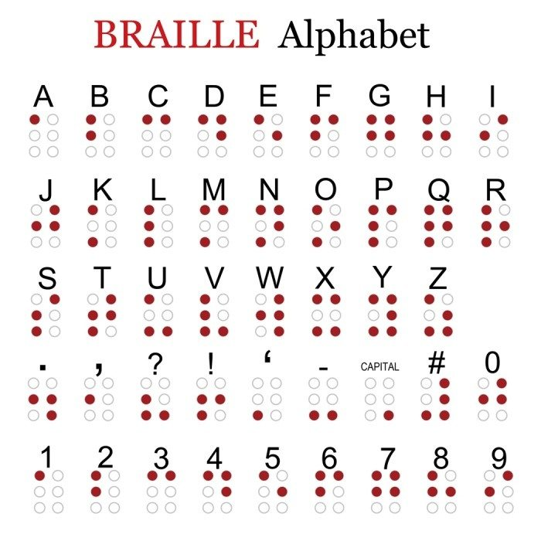

**Fig 2.1 Braille Alphabet**

**Finger Mounted Reading Device:**

**​**This device provides feedback that guides the user’s fingeralong with the line of text, and the system generates corresponding audio in real time.For visually impaired users, this is a conversion. It converts whatever the finger scans to audio. They need fast-real-time feedback to maintain this connection. If it breaks, it breaks the illusion.(Hardesty, 2015)



**Fig 2.2 Finger Mounted Reading Device**

**Reader Pen: ​**

This device is excellent for students with low vision and reading difficulties. Thisdevice has been approved by The Joint Council for Qualifications in the UK for use in exams. The disadvantage of this product is the user with low vision may easily trip off the current line and shift to another line due to negligible friction between paper and pen. (Maxiaids, n.d.)

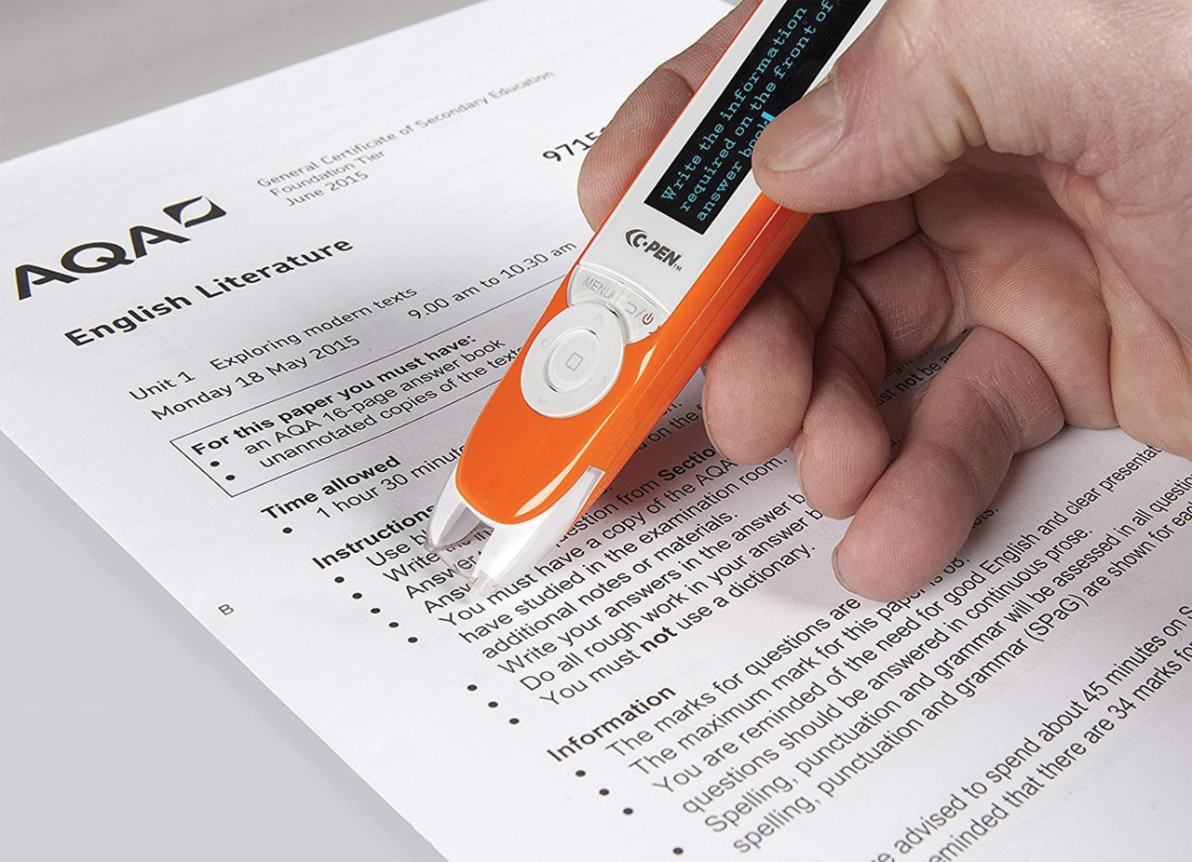

**Fig 2.3 Reader Pen**

**SARA Reading Machine:**

**​**SARA is a perfect machine for seniors who are blind and need materials including books, mail, newspaper, magazines and much more. The User can start SARA right out of the box, with no experience or training.(Nanopac, n.d.)

The disadvantages of SARA reading machineare

* The weight of the device is 8.16 kg which makes it not portable.
* Need to scan every paper of a document(Scanning one paper at least takes 120 seconds).

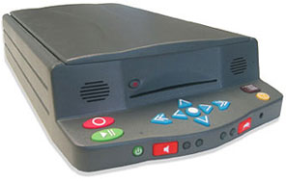

**Fig 2.4SARA Reading Machine**

# **Chapter 3: Requirements / Analysis**

**Need for The System:**

Visually impaired needs a device which can be portable and easy to use. This project is intended to develop a tool which can be portable. A user of the Braille system needs to learn the method and try to implement what they have learned, which is time-consuming. Similarly, finger mounted reading device,and reader pen is portable,butthe ease of use not provideda cause, the user may quicklylose the control of changing lines while reading the document and may end up reading the wrong line of text. Sara reading machine can useideally but it is not portable,and also, the user has to scan the document before reading. Sara reading machine will scan the whole paper and read it to the user.

So, this project triesto eliminate those limitations and develops a primary device without the mentioned limitations.

**Proposed System:**

VIRA (Visually Impaired Reading Assistance) is a device which will read the text from a document for the visually impaired. This device converts whatever text of a document into audio in real time. This system uses both hardware (System on Chip) and software to achieve its implied requisites. The usershould place a document on the reader pad and interact with the system using a couple of buttons provided, to get the desired output (in this case audio with document text). Another option to store the files which are read by the device, in which reader can be able to store the audio files to the google cloud drive storage and can be able to retrieve files whenever he needs those again read those documents.

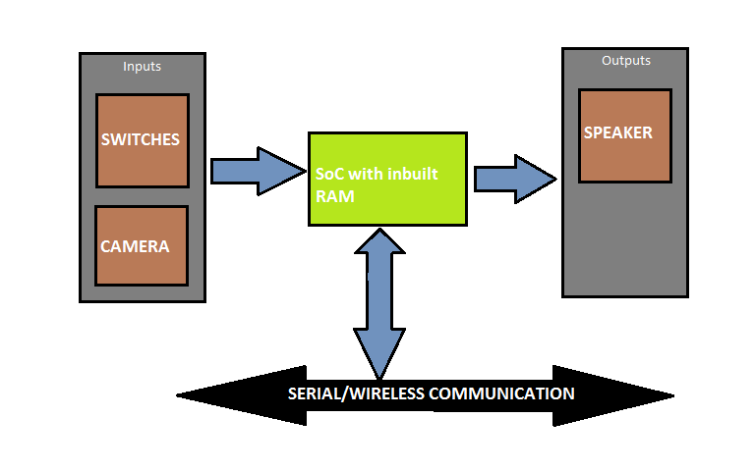

**Fig 3.1Block Diagram of the VIRA**

**System Configurations:**

**Hardware Specifications:**

Raspberry Pi 3,

Camera,

Speakers or Headphones, and

Tact switches.

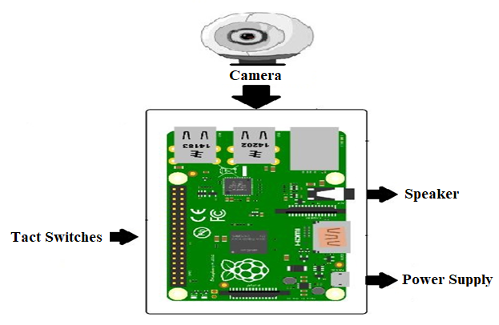

**Fig 3.2Block Diagram of The Hardware**

**Software Specifications:**

Linux operating system (DebianJessi),

Shell scripting, and

Python programming language

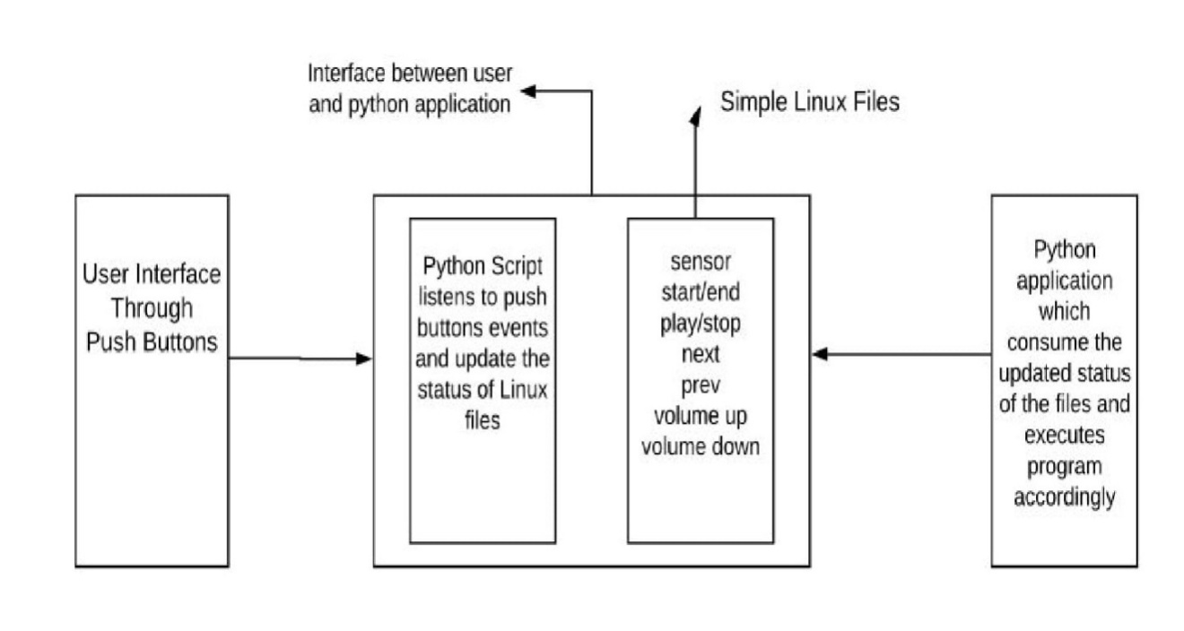

**Fig 3.3Block Diagram of The Software**

**Raspberry Pi 3:**

**​**Raspberry Pi uses ARM BCM2835 SoC which is the secret of how RaspberryPican operate on just 5V 1A power supply provided by the onboard micro-USB port. Raspberry GPIO port is used to communicate with external hardware. Raspberry Pi supports three different types of video output namely composite video, HDMI (High Definition Multimedia Interface) video, DSI (Display Serial Interface) Video. If we use Raspberry Pi's HDMI’s port, audio is natural when correctly configured; the HDMI port carries both video and audio signals.

**Linux operating system:**

**​**Linux is an open source OS based on Unix kernel.The external most layer is applications layer on which user applications reside. Layer precedes external layer is a shell which used as an interface between user applications and kernel. This layer hides the complexity kernel functions from the user. Inner layer precedes shell is called kernel, which is the core component of the operating system, it interacts directly with hardware, provides low-level services to the upper layer.(Bensimon, n.d.)

**Shell scripting:**

**​**A shell is a file containing series of Unix commands. The shell reads this fileand carries out the commands as though they have been entered directly on the command line.

**Python programming:**

**​**Python is a powerful dynamic, interpreted programming language.Some of its features are clear and readable syntax, very extensive standard library, easy to learn, rapid development, debugging, and exception-based error handling.

# 

# 

# **Chapter 4: Design**

**Software design:**

**​**Design of the software achieved through Python programming language.This project uses concepts like multiprocessing and multithreading from python. The software of this project broadly categorized into three primary processes at the core level, namely (i)start-event process, (ii)play-event process, and (iii)push button process

**(i)Start-event process:​**

This button is responsible for the tasks like,

* Taking a picture of the document using the camera,
* Saving the image to the raspberry pi,
* Parsing and converting that image into an audio file,
* Playing audio file for the user using speakers or headphones, and storing audio file to the cloud.

Some of this task can be executed as separate threads while some tasks can execute one after the other.

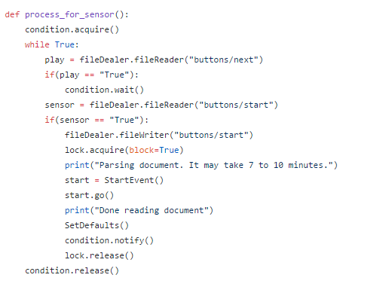

**Fig 4.1 Python Code for Start-Event Process**

**(ii)Play-event process:**

**​**This process is responsible for the tasks like,

* Retrieving audio files from the cloud storage, and
* Playing audio files for the user.

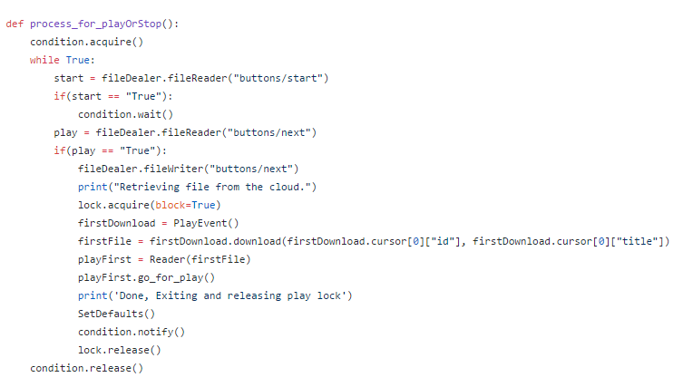

**Fig 4.2 Python Code for Play-Event Process**

**(iii)Push button process:**

**​**This process acts as an interface between the user and thepython program. It uses simple Linux files as a medium to communicate with the program. It merelyupdates the status of files from false to the right,or vice-versa and the program consumes that status to perform the tasks accordingly.

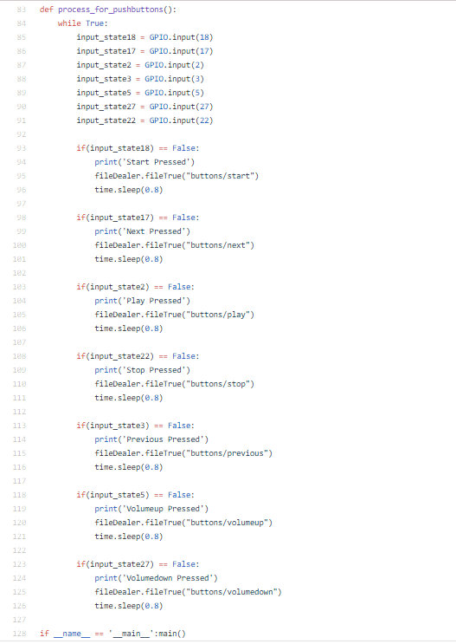

**Fig 4.3 Python Code for Push Button Process**

**Hardware design:**

**​**Project hardware consists of Raspberry Pi as a system on a chip, speaker foraudio, camera to take document picture, and push buttons which act as an interface between the user, and software. After developing and installing software using python programming, push buttons can be connected to raspberry pi using jumper wires. As raspberry pi pre-configured with the required circuits internally for pull-up and pull-down resistor implementation, there is no need to design external circuits for the same purpose. Camera and speakers can be connected to raspberry pi using USB ports.

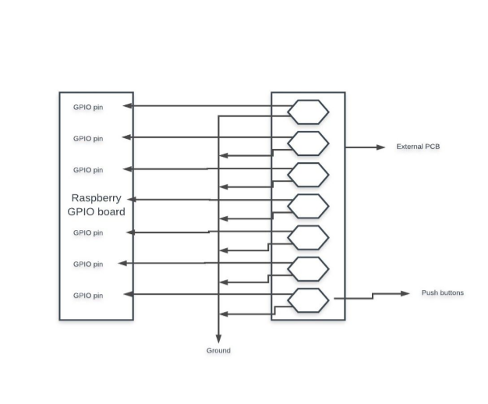**Fig 4.4 Hardware Schematic Diagram**

# **Chapter 5:Implementation and Test**

**Implementation:**

**​**After setting up the raspberry pi, installing required software, and connectingexternal hardware, now it is time to explain the flow of the program which means how the program is implemented for the user to experience the work of the device. As we know, there are a couple of buttons installed on the external circuit. These buttons are namely, start/end, stop, play, next, previous, volume up, and, volume down. All these buttons have corresponding Linux files associated with them such that, whenever the user clicks the button it changes the status of the corresponding file from accurate to false or vice versa. Python processes which are waiting for the status update will identify the change of status and execute the appropriate task. General process flow as described in the following steps.

* As soon as the raspberry pi is turned on and operating system will be booted, this operating system, Linux specifically will start three python processes namely (i)start-event process, (ii)play-event process, and (iii)push-button process.
* Start event process will spawn threads, which are lightweight processes, which can perform specific other tasks like taking document picture, reading the document.
* When the file wholly read, the audio file will save to google cloud storage.
* If in future user has to read the same file, he can retrieve the file from the cloud storage by just pressing next button.
* When the userpresses the next switch, theaudio file will download to the raspberry pi file system,and python program will spawn a thread to play this file.
* The user can be able to navigate through the files in the cloud storage using next and previous buttons.
* The usercan be able to pause and resume the recording using stop and play buttons.
* Lastly, the user can be able to enter and exit from one process to other process using start/end button.

# **Chapter 6:Evaluation**

The evaluation of the system is followed by testing the system and troubleshooting the problems.

**Test: ​**The project’s testing procedure broadly categorized into

* Functional and performance test,
* Stress and output test, and

**(i)Functional and performance test:**

**​** In this type of test system is tested for its functionalrequirements. The test is made to make sure that the functionality of the system is as expected. Every functionality is tested separately for its accuracy and reliability. This test if started earlier, will be much better. The functional test can bedone at the end of the project Individual components and processes can be tested early on, even before it is possible to do functional testing on the entire system. Functional testing means how well the system executes the functionsto execute.Performance testing is testing that performed, determining how fast and accurate some aspects of the system performs under specific workloads.Performance test can demonstrate that the system meets performance criteria. It can measure what parts of the system or workloads cause the system to work efficiently. In performance testing, it is crucial to for the test conditions to be similar to the actual expected use, this is however not entirely possible in actual practice. The function and performance can be improved by increasing the arm frequency, overclocking the CPU and disabling GUI such that CPU will have less load from GPU.

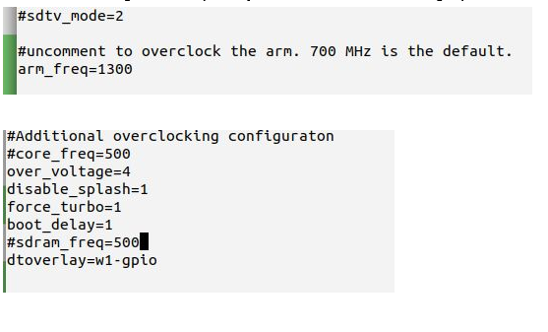

**Fig 6.1 Increasing ARM Frequency and Overclocking CPU**

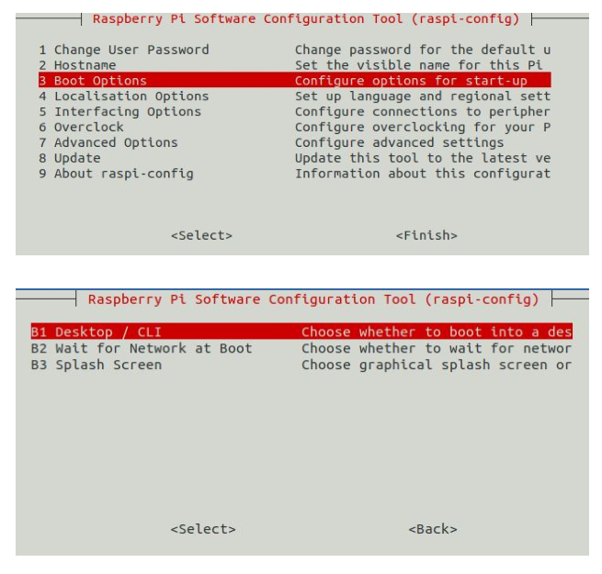

**Fig 6.2Disabling GUI for Text Console**

**(ii)Stress and output test:**

**​**The system is tested against heavy load and for different criteria inour case with different types of documents. This test conditions may not be similar to the actual regular use. This test can be made to determine the pitfalls of the system, which can then be used to conclude the required conditions that user should be aware of, before using the system.

Below are the test results obtained under favorable conditions Fig 6.3 is the image captured by the camera after pressing capture switch,andFig 6.4 is the text obtained after converting the captured image.

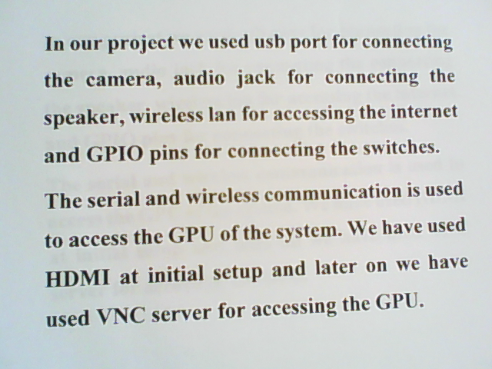

**Fig 6.3 Image Captured by The Camera**

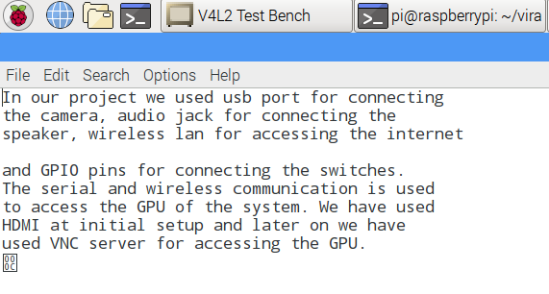

**Fig 6.4 Text Generated After Conversion**

**Troubleshooting errors:**

The switches were not responding the configuration of the switches has been changed and tested. The input states of switch 3 and fourhave been interchanged from GPIO 2 to GPIO 22 so that the switch 3 pauses the playback and switch four resumes the playback

There was an issue for mounting the camera to scan the document which resulted in the generation of the wrongimage with the help of clip lamp the camera mounted on the lamp.

# 

# **Chapter 7:Conclusion**

**Achievements excepted through the project:**

* Comparing to existing manual system, it performs at a faster pace.
* The system gives better feedback when compared to existing systems.
* Timely and accurate.
* The system provides higher processing speed accuracy.
* Chances of errors are much low.
* Time for overall process reduced.
* Ease of operation.

**Future Scope of The Project:**

As our project can be able to extract text from an image of document captured by camera, there are certain requirements that should be taken care while using the device. The font-size of the image in the text should be greater than or equal to 24, and text should be of type of digitally printed but not handwritten cause, our project uses Tesseract-ocr software which has set of trained data through which tesseract-ocr compares and identifies the characters in an image. After identification that characters can be converted into text. Because our project is totally dependent on Tesseract-ocr, and we don’t have any idea about the trained data of tesseract-ocr due to time limitations, The scope of the project is limited to digital content like document with printed characters instead of handwritten.

# **Chapter 8:User Manual**

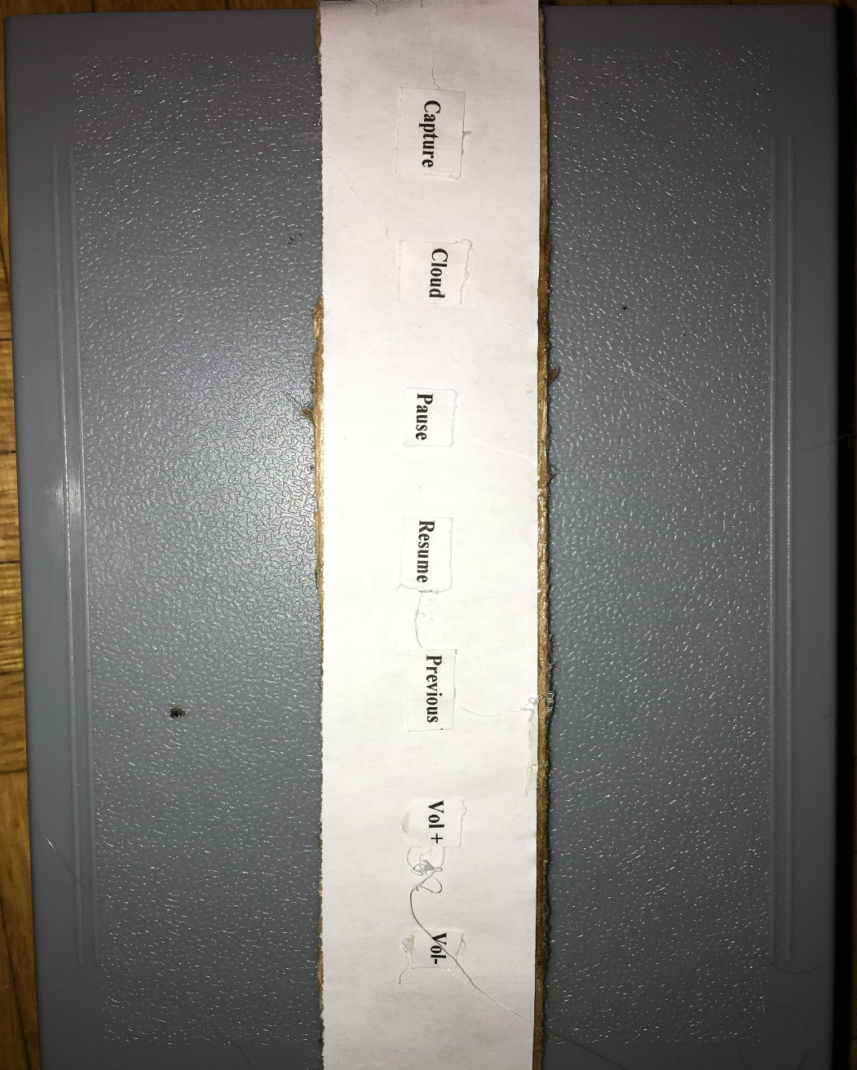

**Fig 8.1 Switches with Various Functions**

The above picture represents the working of switches at different states.

The following steps are needed to be followedby the user

* Switch on the raspberry pi and place the paper with text on the pad.
* Press the switch 1 to capture the image from the camera, and the program will start the conversion process and uploads the audio file to the Google cloud storage.
* Press the switch 2 to retrieve the file from the cloud storage and play the audio.
* Press switch 3 for pausing the playback.
* Press switch 4 for resuming the audio.
* Press switch 5 for playing the previous audio.
* Press switch 6 to increase the volume.
* Press switch 7 to decrease the volume.

# **References**

Bensimon, J. (n.d.). *Linux Essentials*. Retrieved 04 17, 2018, from LOGTEL: http://logtel.com/content/training/computer-tech-skills/linuxunix/linux-essentials

Braille Works. (n.d.). *History of the Braille*. Retrieved 04 16, 2018, from Braille Works: https://brailleworks.com/braille-resources/history-of-braille

Hardesty, L. (2015, 03 10). *Finger-mounted reading device for the blind.* Retrieved 04 2018, 18, from MIT News: http://news.mit.edu/2015/finger-mounted-reading-device-blind-0310

Jameco. (n.d.). *Raspberry Pi*. Retrieved 04 16, 2018, from Jameco Electronics: https://www.jameco.com/Jameco/workshop/circuitnotes/Circuit_Notes_RasberryPiPDF.pdf

Maxiaids. (n.d.). *C-Pen Exam Reader Pen*. Retrieved 04 18, 2018, from Maxiaids: https://www.maxiaids.com/c-pen-exam-reader-pen

Nanopac. (n.d.). *SARA- Scanning and reading Appliance*. Retrieved 04 16, 2018, from nanopac, INC.: http://www.nanopac.com/SARA%20Reading%20Machine.htm